Mental Health and Wellbeing Locals & Mental Health and Wellbeing Hubs factsheet
OFFICIAL

Purpose
This factsheet contains information on what treatments and supports Mental Health and Wellbeing Locals (Local Service/s) and Mental Health and Wellbeing Hubs (Hub/s) offer, the locations of Local Services and Hubs, transitioning consumer services from Hubs to Local Services, and support offered by the Partners in Wellbeing phoneline.

Summary
Victoria’s mental health and wellbeing system is transforming. The final report of the Royal Commission into Victoria’s Mental Health System set a clear vision for a reformed mental health and wellbeing system with services in local communities as the backbone of the system.
- The Victorian Government has committed to establishing 50 Mental Health and Wellbeing Locals by the end of 2026. This new service stream will provide an easy way to get treatment, care and support for people aged 26 years and over who are experiencing mental health concerns – including people with co-occurring alcohol and drug treatment and care needs and their family, carers and supporters. These services require no referral and will be free of charge to consumers.
- Mental Health and Wellbeing Hubs were established in 2021 in response to a need arising during the COVID-19 pandemic. While Local Services are being progressively rolled out across the state, Hubs are still running to ensure no one falls through the gaps.
Victorians can use the new Local Services and Hubs to access mental health and wellbeing support closer to home. People who use the Hubs will be supported to access the new Local Services, if appropriate, as they become available.
Partners in Wellbeing is a helpline that supports people to access Local Services and/or Hubs.

Getting support from a Mental Health and Wellbeing Local or Hub
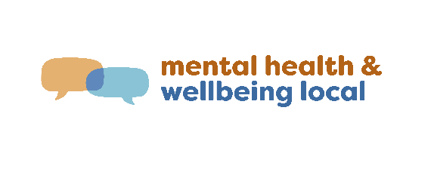 | 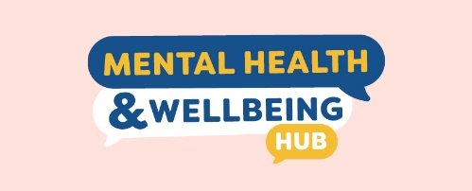
Local Services offer treatment, care and support for adults and older adults aged 26 years and over and their family, carers and supporters who are experiencing mental health or wellbeing concerns. Support is also available for anyone who is experiencing mental health and substance abuse concerns at the same time. | Hubs support people of all ages and their family, carers and supporters to address mental health and wellbeing needs caused by the stressors and concerns as a result of the COVID-19 pandemic. Hubs complement clinical interventions and treatment by actively supporting people recovering from mental-ill health.
No referral is needed from a GP or health professional to access support through a Local Service or Hub. Both services are free.
The Local Services offer:  - treatment and therapies  - person-centred wellbeing supports  - education, peer support and self-help  - consumer-led care, planning and coordination to link across other services  - social and community connections. | The Hubs offer:  - short term wellbeing support tailored to a person’s individual needs  - social and community connections to support personal recovery, as well as linking across services and helping people, their family, carers and supporters to manage stressful situations, such as threats of homelessness, financial difficulties and social isolation.
Local Services provide face-to-face, telehealth and mobile outreach services one-on-one or in groups.  The Benalla, Greater Geelong-Queenscliffe and Brimbank Local Services are now accepting walk-ins. | Hubs provide a mix of face-to-face support, telehealth, mobile outreach, online delivery and walk-ins.
Information for consumers, carers, families and supporters is on the Better Health Channel website  <https://www.betterhealth.vic.gov.au/mhwlocal>. | Information for consumers, carers, families and supporters is on the Better Health Channel website  <https://www.betterhealth.vic.gov.au/mental-health-and-wellbeing-hubs>.

Where are the Local Services?
Local Services locations | Providers of Local Services
Benalla-Wangaratta-Mansfield | Wellways Australia in partnership with Albury Wodonga Health and Australian Community Support Organisation (ACSO)
Frankston | Wellways Australia in partnership with Peninsula Health and Mentis Assist
Brimbank | cohealth in partnership with Clarity Health Care and the University of Melbourne
Greater Geelong-Queenscliffe | Barwon Health in partnership with Wellways Australia, ermha365 and Wathaurong Aboriginal Co-operative
Latrobe | Neami National in partnership with Drummond Street Services and Uniting Vic.Tas
Whittlesea | Neami National in partnership with Drummond St Services, Uniting Vic Tas and Victorian Aboriginal Health Service.

New services located in Dandenong, Shepparton, Melton, Mildura, Lilydale, Bendigo-Echuca and Orbost-Bairnsdale are set to open by the end of 2023.

Where are the Hubs?
19 Hubs will continue offering support to Victorians for another year, while Local Services are being progressively rolled out across Victoria.
Regional Hubs will continue supporting Victorians in Ballarat, Bendigo, Cowes, Horsham Mildura, Narre Warren, Shepparton, Warrnambool and Wonthaggi.
In the Melbourne Metro region, Hubs will continue to provide support in Abbotsford, Boronia, Box Hill, Cheltenham, Coburg North, Craigieburn, Footscray, Greensborough, St Kilda and Werribee.

Transitioning your support from a Hub to a Local Service
As the Local Services are established, Hubs in the same area will slowly phase down.
People aged 26 years and over who are being supported by a Hub in an area where there is a Local Service will have the option to transition across to a Local Service or other appropriate provider.
Staff from the Hubs and Local Services will support and work with consumers and their families, carers and supporters to develop and implement a consumer centred transition plan that will focus on achieving continuity of care for people transitioning from a Hub to a Local Service.
If you are a young person, Local Services may provide support in some situations, such as:
- you contact a Local Service for help
- you are having difficulty getting support through headspace or a hospital and need immediate assistance
- you are a family member, carer, friend or supporter of a person receiving support from a Local Service.

Partners in Wellbeing
Partners in Wellbeing is a free, statewide, phone-based helpline and wellbeing support service. It offers one-on-one wellbeing coaching for people aged 16 years and over who are experiencing symptoms of psychological distress or mental-ill health. Partners in Wellbeing supports people to access the Local Services and Hubs.
For more information about Partners in Wellbeing, Hubs and Local Services, please contact Partners in Wellbeing via:
- Phone: 1300 375 330 or
- Partners in Wellbeing website & webchat <www.partnersinwellbeing.org.au>.

To receive this publication in an accessible format phone (03) 9096 7183 using the National Relay Service 13 36 77 if required, or email localservices@health.vic.gov.au
Authorised and published by the Victorian Government, 1 Treasury Place, Melbourne.
© State of Victoria, Department of Health, July 2023.
ISBN 978-1-76131-190-1 (pdf/online/MS word)

